Brand

PART 1 : brand value

Capital de la marque/ notoriété: brand equity
Force/ faiblesse : aptitude qu’on contrôle
Opportunité/ menaces : aptitude qu’on ne contrôle pas et qui influence notre entreprise

Definition brand: brand culture is the set of shared values, beliefs, behaviors and symbols that shape how a brand is created, expressed, and experienced by all its stakeholders both inside the organization (employees, leadership) and outside (customers, partners, communities)
It is the personality of a brand reflected by:
- What the brand stands for (vision, purpose, values)
- How it acts (customers interactions, employee’s behaviors, business decision)
- How it communicates (tone, storytelling, symbolism)
- How it is perceived (reputation, associations, customer experience)

The 3 main component of a strategy:
- Vision
- Mission
- Values

Google: brand culture of innovation and openness, expressed in its playful tone, internal work culture, and product design

Harley Davidson: brand culture of Freedom and rebellion, reinforced through its biker community and lifestyle positioning

The brand is value creation: brand have evolved far beyond simple logos and slogans

Les 3 types de chaine de distribution:

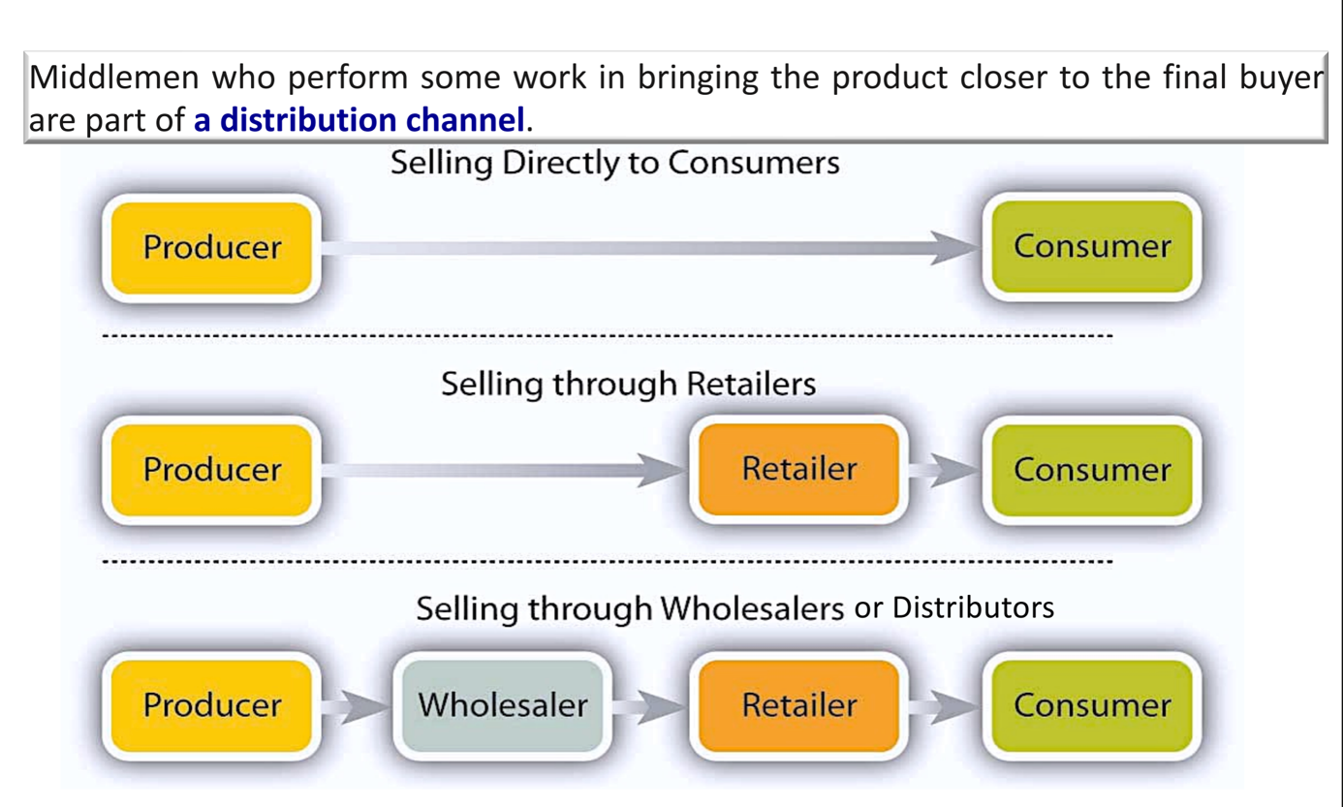

Retailer = détaillant
Wholesaler= grossiste

3 types of distribution:
Intensive: product that you can find everywhere
Selective: a selective stand in a resale store (Longchamp in gallery Lafayette for example)
Exclusive: top, premium prices (Rolex, Ferrari….)

Why brand value matters:

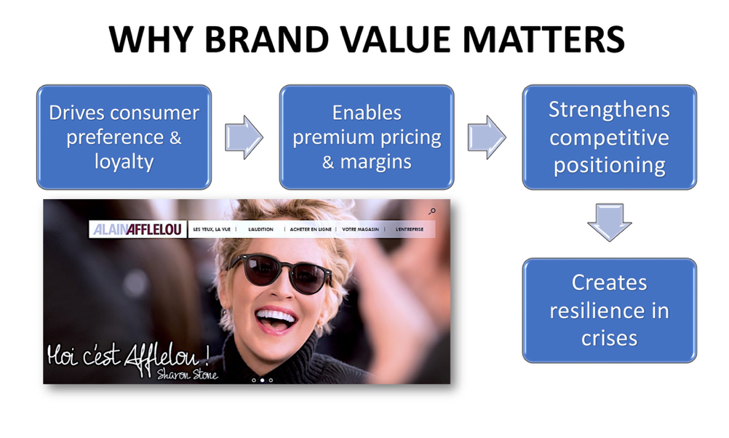

Make my competitive advantage sustainable
CA= competitive advantage
USP= unique selling proposition

- Manufacturers, sources of brand value

Product quality and innovation: delivering superior performance or innovation builds trust and loyalty

Brand quality and recognition: the strength of their brand name translates into customer preference and pricing power

Heritage and storytelling: long-standing history or strong brand narratives create authenticity

Marketing investment: brand building campaigns, endorsements, and sponsorships reinforce brand presence

Intellectual property: trademarks, patents and design rights protection

Apple (manufacturer):
- Creates value through product design, software integration, and innovation (iPhone, mac)
- Its powerful brand equity allows Apple to command premium pricing and expand into services (Apple music, iCloud)

Quality message: gerblé
La promesse: un aliment sain
La preuve: un expert en diététique + la composition detaillée du produit
Le benefice: le consommateur mange sain et il le sait
Le ton: le ton de l’expert, du conseiller

Hermes: flagship store car vitrines pour les marques

Tesla’s example:
Manufacturer: builds brand equity through innovation (EV’s, autonomous technology)
Distributors: DTC (direct to consumers) -> reinforces exclusivity
Retailers: tesla’s retail stores (experience-focused) elevate the premium brand perception
Consumers: act as brand evangelists, sharing experiences online, strengthening the community and adding credibility

Customer relationship management (GRC en français)
Every brand has a CRM platform (plateforme qui collecte les données des clients)

- Distributors, sources of brand value

- Association with strong brands: distributions well-know brands enhances their credibility
- Reliability and trust: delivering brands to market builds reputation with both retailers and manufacturer
- Exclusive distribution rights: being the only distributor of a brand generates bargaining power
- Market coverage & reach: the ability to make a brand available across countries adds value.
- After-sales support: Providing warranty or technical support strengthens brand reliability

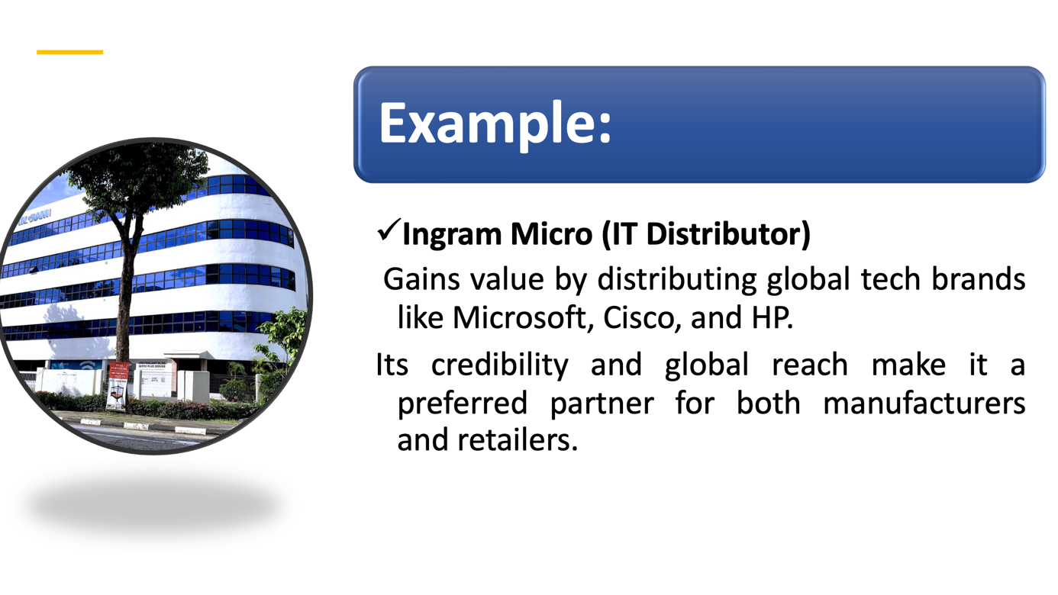

- Retailers, sources of brand value

- Shelf space & visibility: premium placement in-store or online boosts brand
- Customer experience: a retailer’s ambiance, service quality, and digital UX (user’s experience) elevate the perceived value of brands they carry
- Private labels (marque de distributeur) & co-branding: retailers create their own brand value (e.g., Walmart’s great value, amazon basics) -> they can be less expensive, and it is very useful against the concurrent
- Consumer trust & loyalty programs: strong retailer brands (e.g., Sephora) amplify the brands they sell
- Channel control: exclusive launches or collaborations (e.g., sneakers drop at Foot Locker) enhance desirability

Si on réduit l’offre on peut augmenter les prix -> on augmente le manque chez les clients, ça fait croire aux clients qu’ils sont special, qu’ils font partie d’une communauté = rarefaction du produit (scarcity in English)
Qualité: on ameliore que ce que l’on mesure et on mesure que ce que l’on définit
Audit: démarche qualité
R&D: research and development
CA= competitive advantage (avantage concurrentielle)

Example: sephora (retailer)
- Elevates luxury beauty brands by providing experiential retail (sampling, expert advice, loyalty programs)
- Sephora’s own strong retail brand also boosts consumer trust in new or niche brands (leader, challenger, follower, nicher), it introduces -> exemple d’entreprise niche: Allianz Defense Security -> assurance qui défend les militaires qui risque de mourir

SCP (STP: segmenting, targeting and positioning):
Segmentation: definir une clientele qui aura des caracteristiques ressemblant pour positioner son produit
Ciblage: Coeur de cible
Positionnement: positionné le produit à travers le segment

- Consumers (end-users, decision-makers)

End-users = utilisateurs finales
USP: unique selling proposition

- Perceived quality & status: the brand’s image (luxury, eco-friendly, affordable) drives personal identity expression
- Emotional connection: stories, values and social causes resonate and build loyalty
- Word of mouth & social proof (qu’est ce qu’ont fait les autres qui me donne envie de faire la même chose): positive reviews, social media posts, and influencer advocacy amplify brand equity
- Community & belonging: some brands foster tribes (e.g., Harley-Davidson riders, Apple users)
- Price sensitivity & loyalty: willingness to pay a premium or remain loyal underlines brand strength

Example: Nike
- Consumer lens
- Nike’s brand value grows as consumers embrace it not only for product performance but also for identity (“just do it”), alignment with social causes
- User-generated content on Instagram or TikTok further co-creates brand equity

Empowerment: responsibilities, autonomisation

Don’ts in brand names:
- Difficult spelling
- Hard to pronounce

Packaging: it plays an important role in the consumer’s purchasing decision. Anything from print to online and physical assets, such as logo, brand colors, and even the font you use on your website.

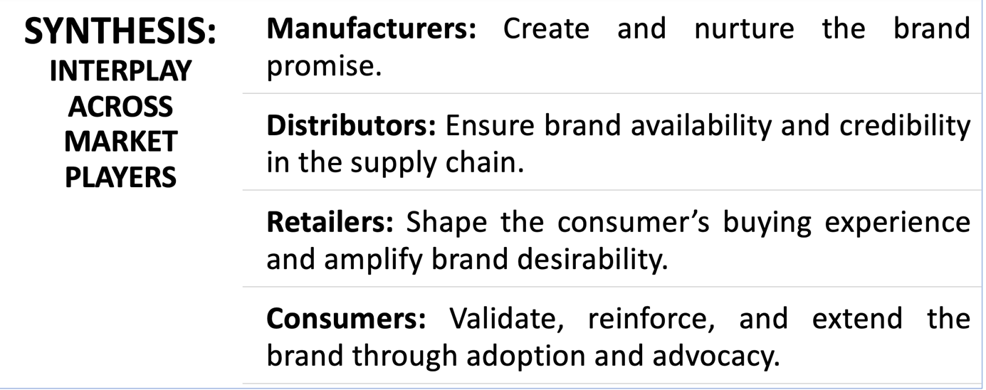

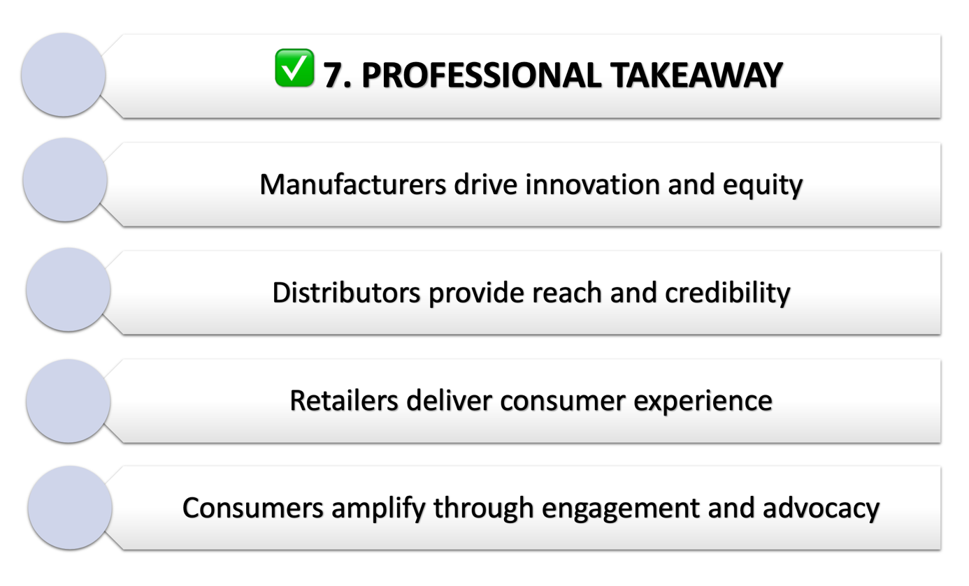

Example | Sector | Brand meaning | Customer’s interpretation & experience
Apple | Technology | “Think different” ->  Creativity, individuality, innovation | Big customer service and quality performance
Nike | Sport lifestyle | “Just do it” -> be strong and be powerful with Nike clothes, shoes | Adapted to your performance, expert advice
Patagonia | Outdoor / Apparel | “We the power”  Sustainability, environmental activism | Ethical consumption
Starbucks | Coffee/ food | “to inspire and nurture the human spirit- one person, one cup and one neighborhood at the time”  Community, comfort | Vibes of starbucks, personal and cozy experience
Lego | Toys to build | “Learn by playing” having fun while being patient | It’s for every age and every gender
L’Oréal | Cosmetic | “parce que vous le valez bien”, feeling pretty with good products | A unique experience because you feel powerful

PART 2: brand management

- Brand culture vs corporate culture

Corporate culture: the international environment of an organization (the values, norms, leadership style, and work practices that shape how employees behave and interact)

Brand culture: the externalized identity of a company (the values, beliefs, and behaviors that are consistently expressed through the brand and experienced by customers, employees and the wider public

- The brand life cycle

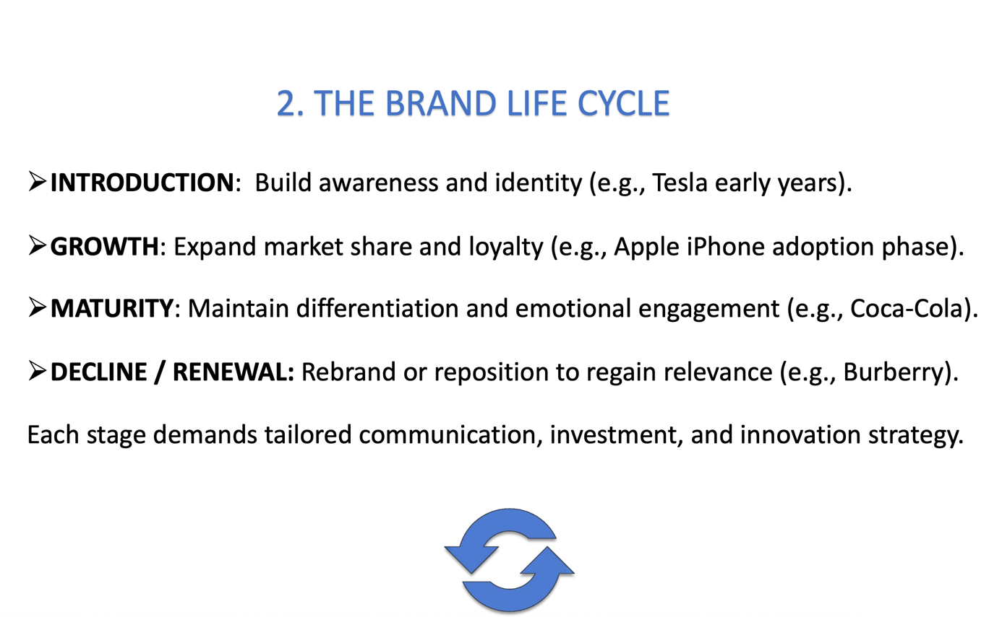

1-> segment
2-> targeting
3-> positioning

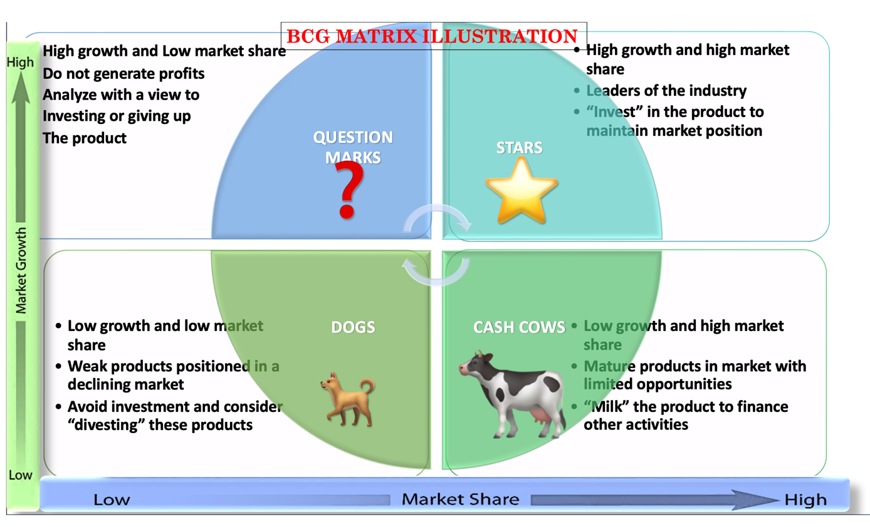

The BCG matrix evaluates a company’s portfolio (products, business units or market) based on:
- Market growth rate. (industry attractiveness)
- Relative market share (competitive strength)

4 quadrants:
- Stars: high market growth, high market share
- Cash cows: low market growth, high market share
- Question marks: high market growth, low market share
- Dogs: low market growth, low market share

Nespresso example:

Step 1: define the scope
Consider Nespresso Europe, focusing on:
- It’s core product lines (original, vertuo, professional)
  - Original: compatible capsule systems
  - Vertuo multi size capsule systems
  - Professional: office capsule system -> big box

Step 2: market overview
- Europe is a mature, saturated coffee capsule market
- Growth is moderate with sustainability and premiumization
- Nespresso faces strong competition from brands like l’or, Lavazza, starbucks

Step 3: relative market share (RMS)
Nespresso line’s market share divided by market share of largest competitor in same segment

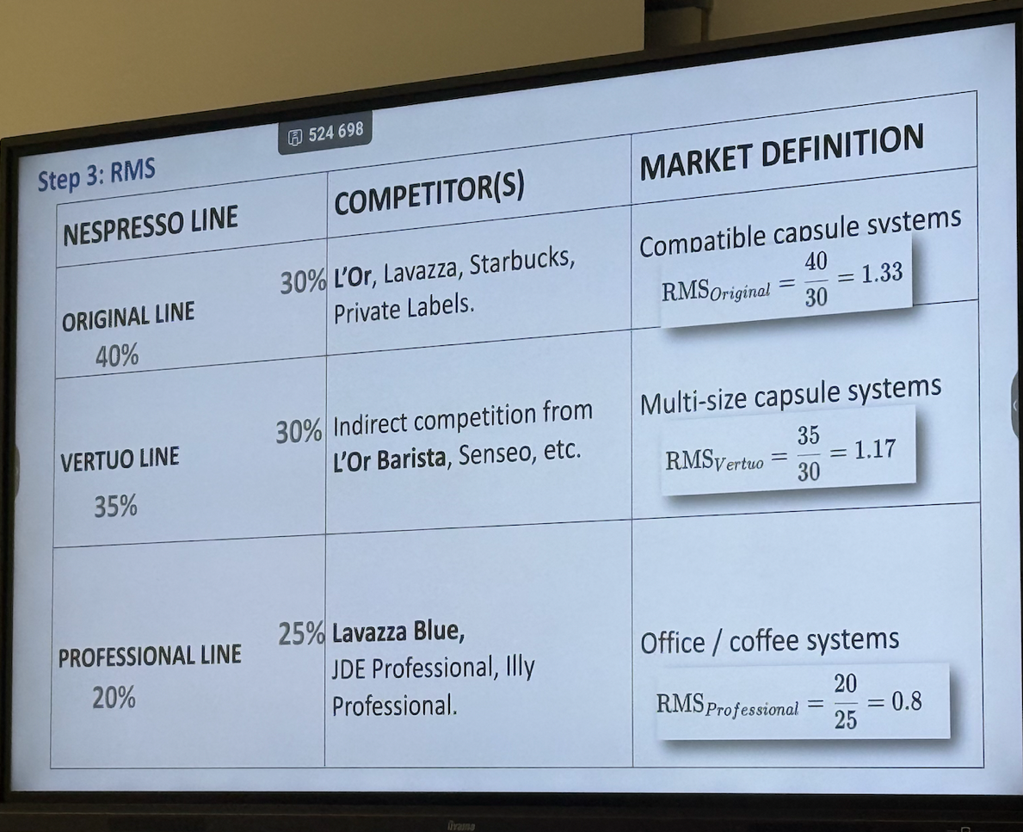

Summary table (BCG positions)

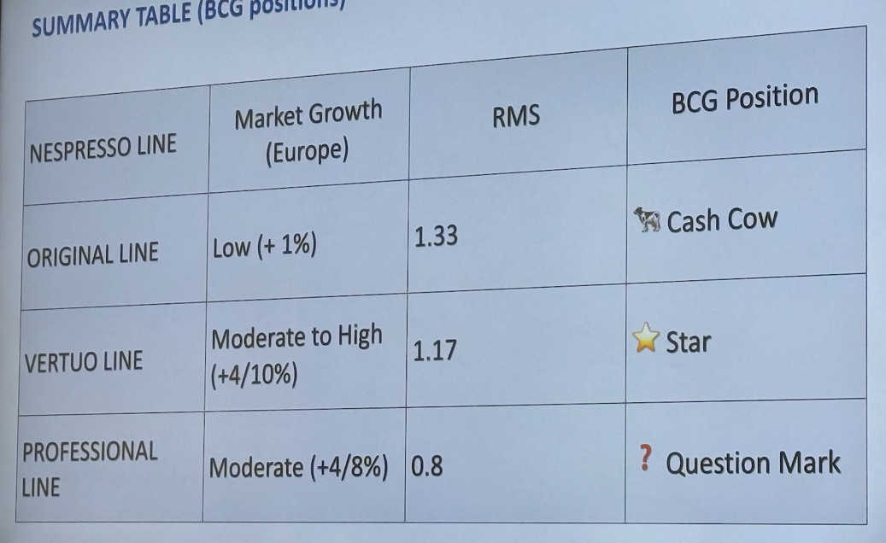

Step 4: strategic recommendations
- Milk cash cows (original line)
Objective: Maintain profitability in the mature espresso capsule segment
Actions:
- focus on customer retention via loyalty programs (Nespresso Club, sustainability rewards)
- emphasize recycling and refillable capsule initiatives to protect brand equity and meet EU sustainability regulations
- Optimize operational efficiency in supply chain and prioritize innovation only in flavors, seasonal offerings, and packaging

- Invest in stars (Vertuo line)
Objective: strengthen position in its high growth segment
Actions:
- Expand vertuo system distribution across Europe, especially in emerging coffee capsule markets (e.g., Eastern Europe)
- Increase marketing and awareness around crema quality and capsule innovation
- Use personalization and digital platforms (app integration, subscriptions) to lock in customers and to counteracts l’or barista through exclusive partnerships and limited-edition blends

- Reassess B2B (professional)
Objective: boost growth in offices and hospitality channels
Actions:
- Offer customized subscription packages for small offices and co-working spaces
- Strengthen partnerships (hotels, restaurants, cafés) with sustainable and premium offerings
- Explore cross-selling with Nestlé Professional portfolio for synergy and scale

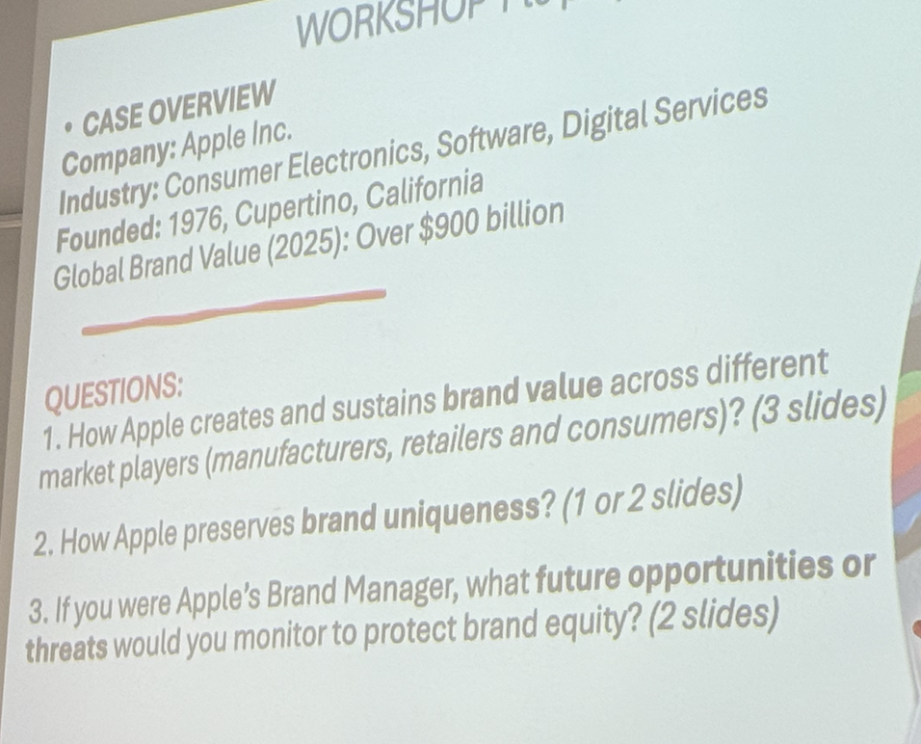

Source of brand value:

Manufacturers:
- Product quality & design excellence: seamless integration of hardware and software (e.g., Iphone, Macbook, AirPods)
- Innovation & R&D: Continuous investment in chips (M-series), AI and connectivity -> entry barriers
- Brand narrative: “think different!” A brand ethos rooted in creativity, simplicity and empowerment
- Sustainability: commitment to carbon-neutral operations and recyclable materials reinforces brand trust
- Intellectual property: patents, software ecosystem and closed design preserve uniqueness

Retailers:
- Apple stores: minimalist, design-led spaces that reflect the brand’s philosophy (clean, intuitive, inspirational)
- Customer experience: trained staff provide guidance rather than sales pressure
- Loyalty and service: repairs, upgrades and service reinforce the sense of belonging to the “apple ecosystem”
- Retail partnership: premium resellers like Best Buy replicate Apple’s retail experience standards
Apple’s retail strategy transforms shopping into a brand immersion experience, turning stores into temples of the brand

Consumers:
- Emotional bonding: users identify with apple’s lifestyle and design philosophy (“it just works”)
- Social proof: owning apple products signals taste, status and creativity
- Community advocacy: user communities, influencers, and fan groups reinforce brand desirability online
- Digital Ecosystem Lock-In and Feedback Loop: iCloud, App Store, and cross-device integration increase loyalty. Apple gathers user feedback to enhance UX and innovation
Consumers are not just buyers; they are brand evangelists who co-create apple’s brand equity through continuous engagement

How apple preserve uniqueness?
- Consistency and quality control -> Every device works seamlessly with others (iPhone <-> Mac <-> iPad <-> AirPods). This consistent performance reinforces the perception of superior quality and reliability
- Distinctive user experience -> The “apple feel”: smooth interface, minimalist design, intuitive usability is the result of complete control. This creates an experience; competitors find hard to replicate
- Brand differentiation -> By not adopting open platforms like android or windows, apple remains distinct. The ecosystem becomes a brand signature, symbolizing exclusivity and innovation.
- Protection of intellectual property -> By keeping design and system architecture closed, apple minimalize imitation and maintains its premium positioning
- Distribution and experience -> Apple’s selective distribution and high-end stores make sense for a luxury tech brand
- Emotional Capital Barrier -> Apple’s lifestyle appeal tool decades to build. New brands often lack that symbolic power

Opportunities:
- Emerging market growth -> India, southwest Asia and Africa present opportunities for brand expansion via locally relevant pricing strategies
- Expansion of the ecosystem -> continue integrating AI, wearable and smart home devices (apple vision pro, home pod, etc…) and experiences such as health, fitness+ iCloud+, apple Intelligence
- Sustainability leadership -> position apple as the global benchmark for green innovation (carbon-neutral supply chain, repairability, circular economy) enhancing ethical appeal
- Service growth and AI with personalization -> grow apple’s revenue via content (Music, TV+, Arcade, Pay, Cloud), reinforcing emotional connection

- Brand Architecture

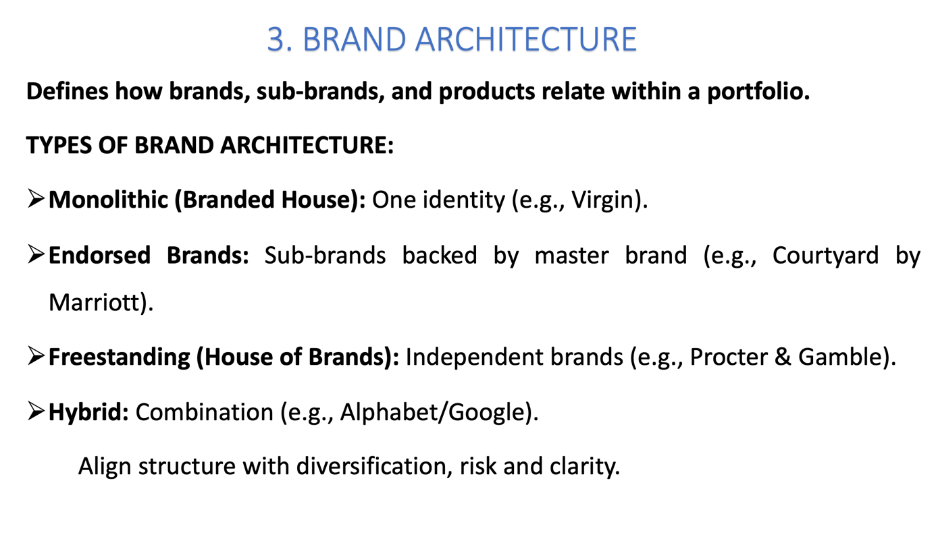

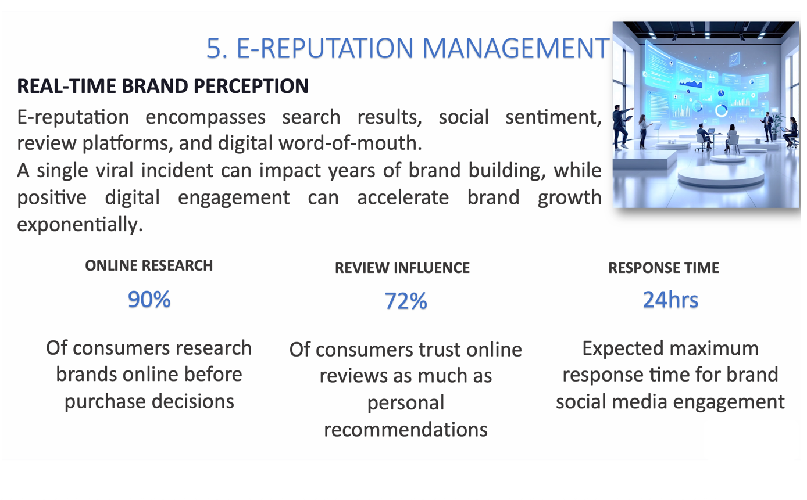

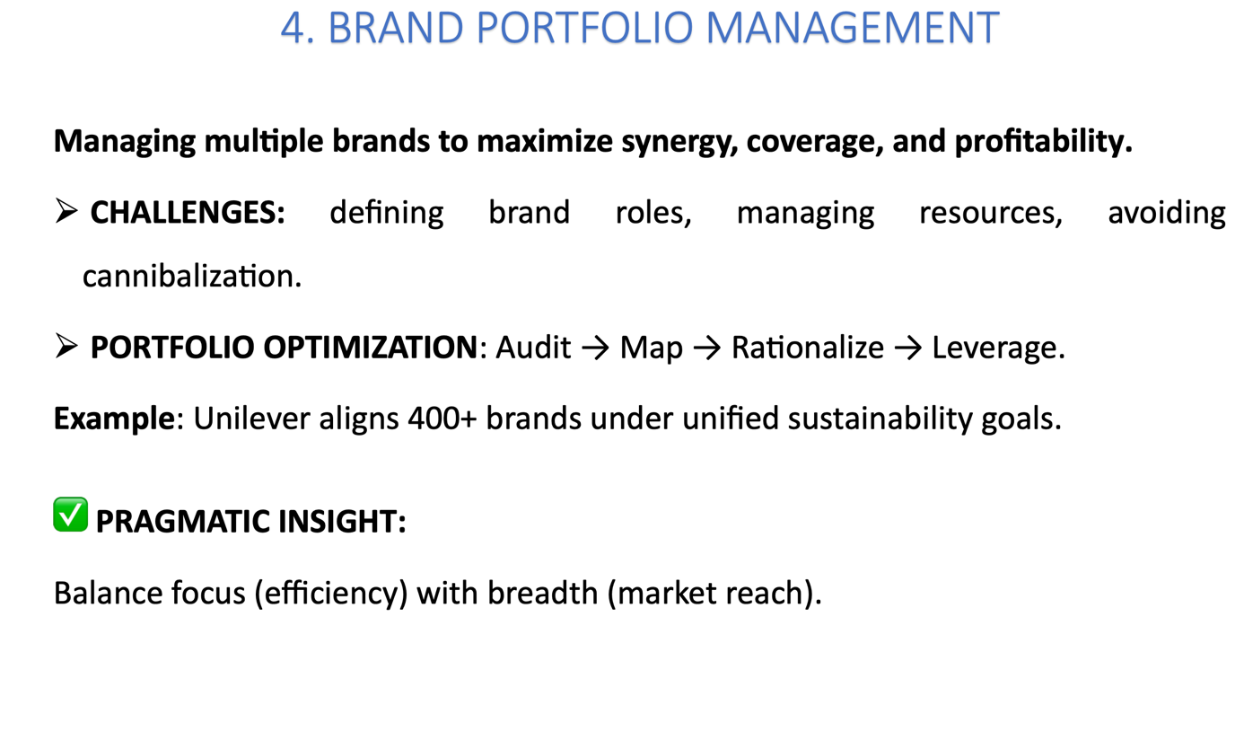

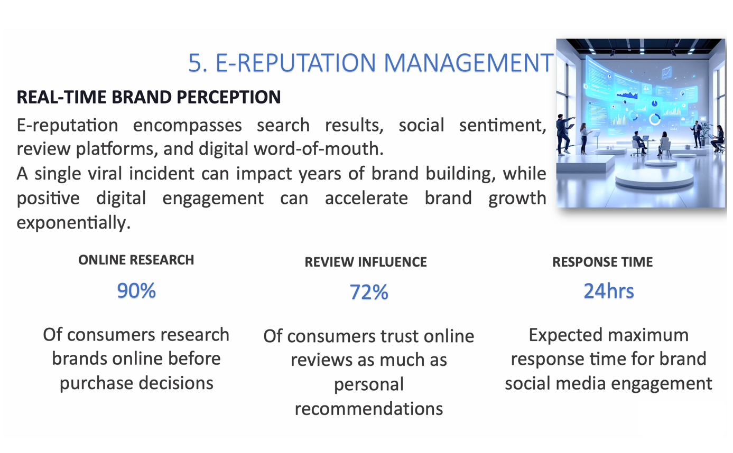

6- Integrated brand management framework

Lifecycle management: sustain brand relevance over time
Architecture design: clarify identity and hierarchy
Portfolio optimization: maximize synergy and reduce overlap
e-reputation: maintain trust and engagement online

= modern brand management -> being authentic, agile, digital

